**Solution 1:**

1. Create Pivot Table from the available Data.

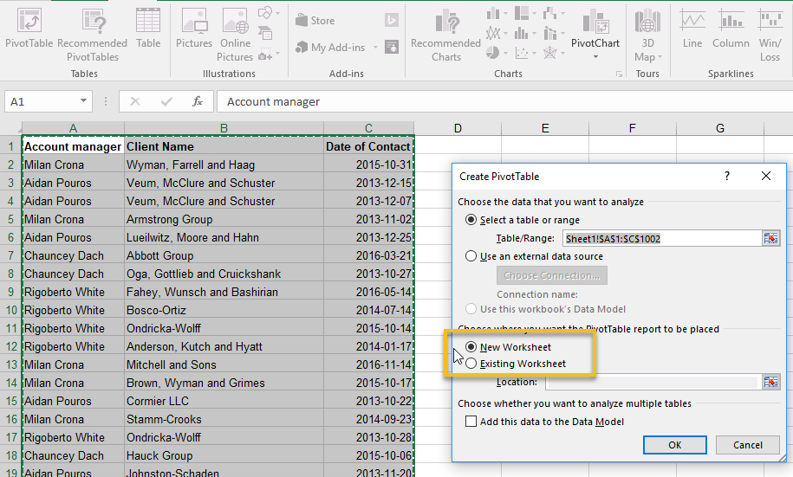

1. Add “DateOfContact” and “AccountManager” fields to Rows section in Pivot Table. Add “Account Manager” to value section and choose type of calculation as “Count”

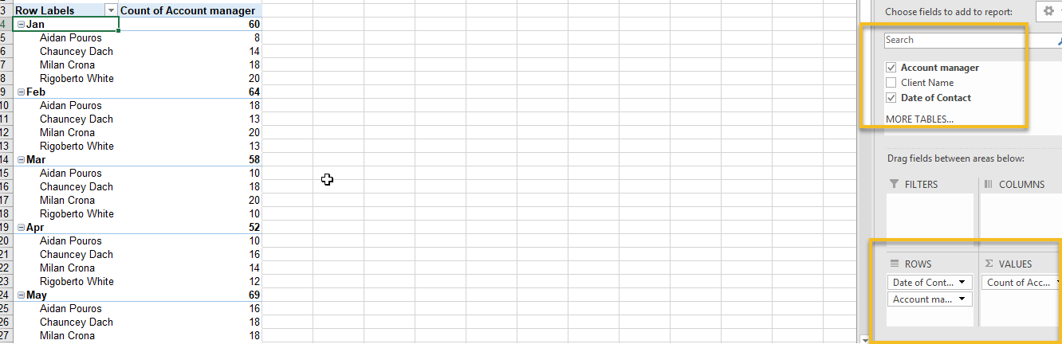

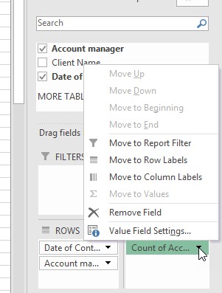 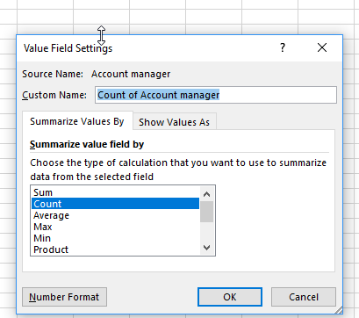

1. Sort Data in descending order 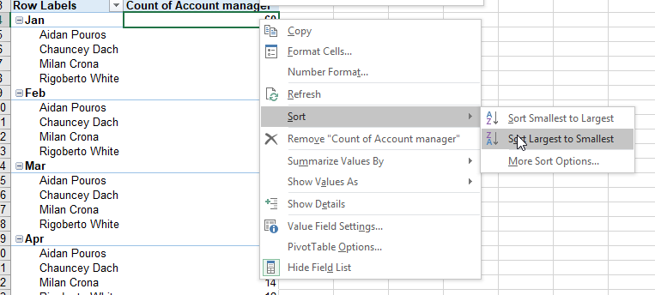
2. Add Pivot Chart to view the data in pictorial representation.

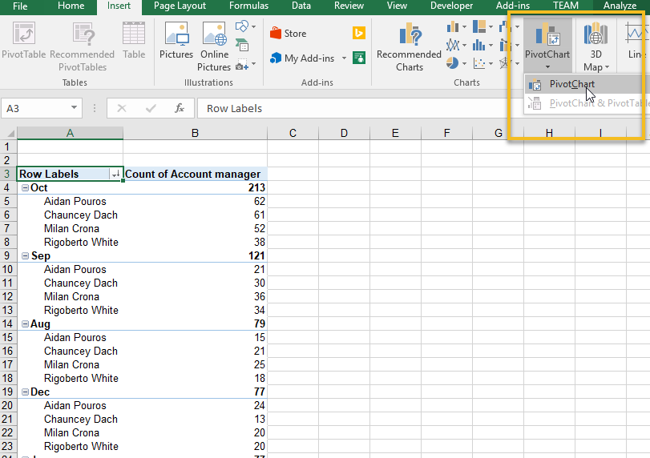

1. Select Column Chart from the Chart Options.

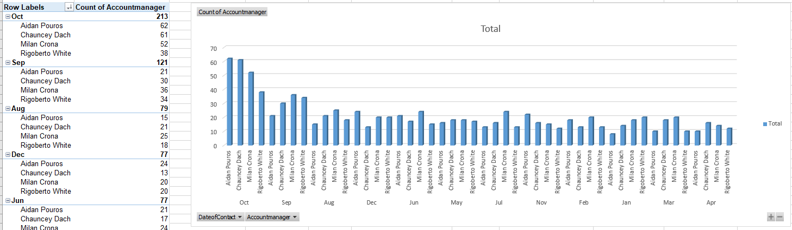

**From the Data above, we know that October month is most likely month to contact most of the clients to schedule a product upgrade.**

**Solution 2:**

1. To drill down all the clients for that account manager, add “Client Name” to the Row section in Pivot Table.

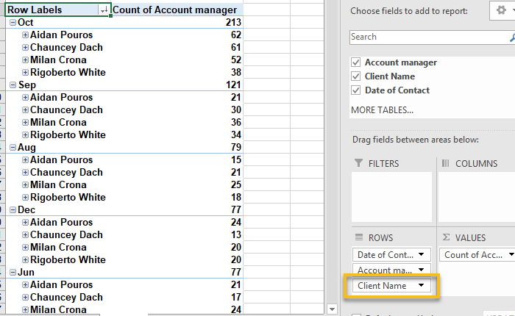

1. Sort Client Count by descending Order

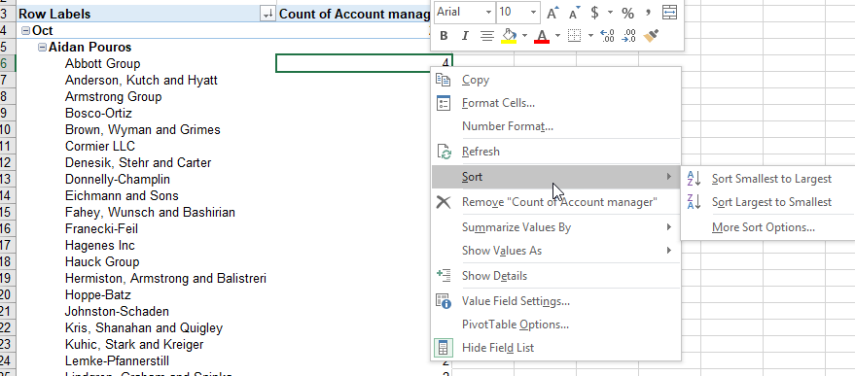

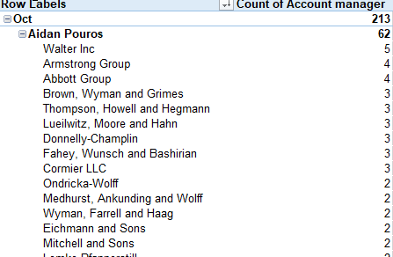

1. For pictorial representation we can slice the data by “Date”.

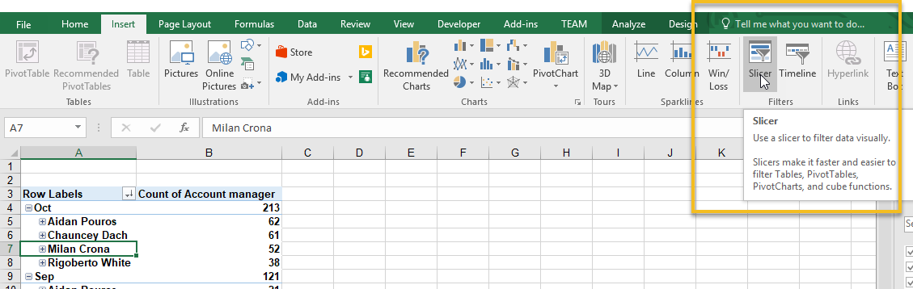

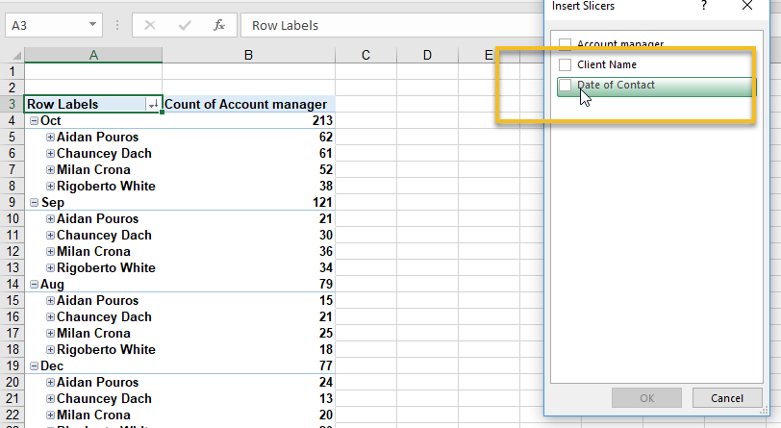

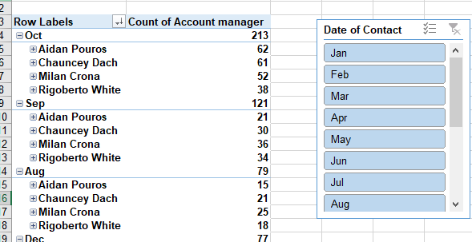

1. Add Bar Graph to show the count by month

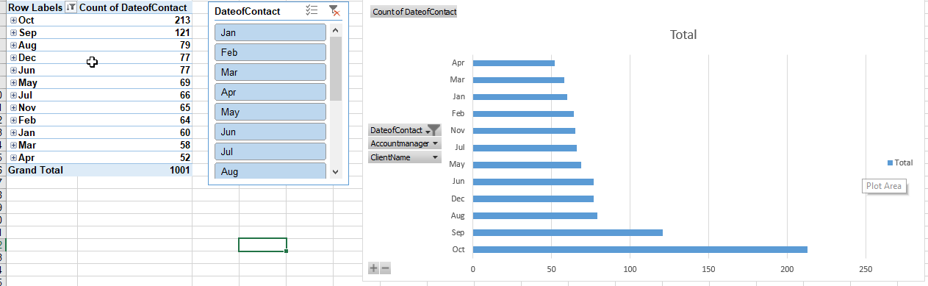

1. Select “October” and the graphs are auto populated based on the selection.

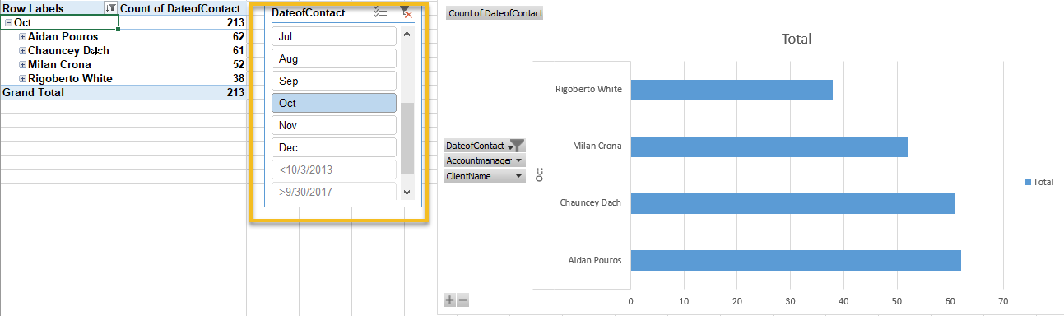

**Above picture shows that October month is most likely month to contact most of the clients to schedule a product upgrade. Provides list of Account Manager and its Client Names.**